FOR RELEASE SINCE 10 JULY 2020
The 3rd Game Music Festival in Poland
16-17thof October 2020
Baldur’s Gate III, Divinity: Original Sin II, Transistor, Hades, Pyre, Bastion. The amazing music from these games will be performed live in Wroclaw, Poland, during a festival fully devoted to the soundtracks of video games. A strictly limited amount of tickets is available for purchase. The event will be also streamed online.
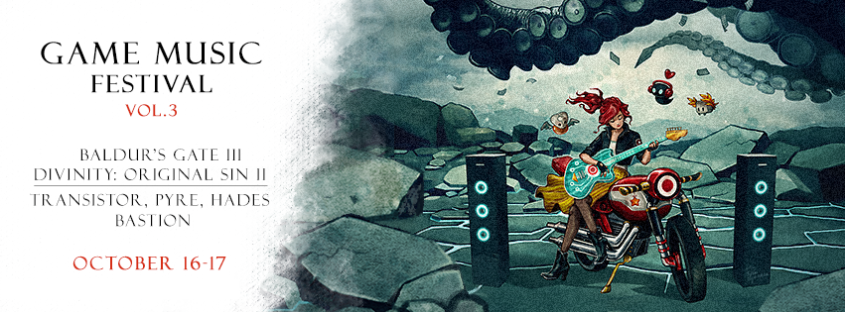
Published on 10th July 2020 – The details of the third edition of the Game Music Festival in Wroclaw, Poland have been unveiled. A fully-fledged festival of this scale dedicated to the soundtracks of video games is a truly unique event. During the 16th and 17th of October 2020, the prestigious stage of the National Forum of Music will be filled with music known from titles produced by Larian Studios and Supergiant Games. The previous editions of Game Music Festival received much praise and were praised by fans and composers alike, attracting an audience of over 10,000 participants total. There will be multiple accompanying events this time as well. The whole initiative is organized by the Game Music Foundation, and tickets are already available for purchase.
Due to the pandemic situation, this year’s GMF will take place in a hybrid format – all concerts will be also transmitted online. Safety is the top priority for organizers, hence the amount of tickets for this edition is strictly limited, in order to enable proper social distancing rules among the audience. Those fans who purchase the limited entry passes will be able to hear and see the performances live on stage, a truly one-of-a-kind experience. Given the unusual circumstances, organizers decided to prepare professional streaming online, so that fans worldwide can participate in the festival remotely, free of charge.
The Symphony of Four Worlds is the first concert of this year’s Game Music Festival. It is an opus that pays homage to four amazing games: Transistor, Hades, Pyre, Bastion. Each of them has earned a special spot in the hearts of gamers also thanks to the awesome music by Darren Korb whose eclectic style is their common denominator. These diverse soundtracks will be presented live in surprising arrangements by the Sound Factory Orchestra, conducted by Robert Kurdybacha, who delivered incredible performances during previous GMFs. This time they will take the listeners on a journey across the visionary worlds by Supergiant Games.
The second concert of the festival will be The Symphony of Sin, a true delight for all RPG enthusiasts. Fans will hear the world premiere of music from Baldur’s Gate III, the upcoming continuation of cult classic games set in the Dungeons & Dragons universe. Furthermore, the other main ingredient of this event is the soundtrack of Divinity: Original Sin II – the critically acclaimed flagship title by Larian Studios. Both of these were composed by Borislav Slavov, and will be performed live by the seasoned NFM Philharmonic.
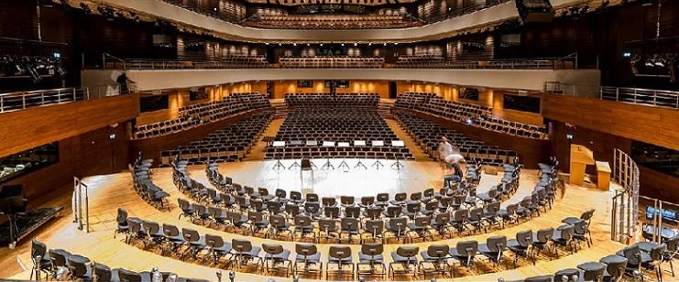
As the organizers explain: “This year is different for us for obvious reasons. Thus we want to meet the expectations of our fans by preparing a high quality streaming of both concerts. A professional transmission will be available online for free. We are also planning to invite some special guests onsite, if only the regulations allow us to. Nevertheless, masterclass workshops and meet & greet sessions are also possible remotely. We focus on the highest artistic quality, so once again we decided to cooperate with the National Forum of Music which has one of the best philharmonic halls in the world in terms of sheer acoustics.”

Tickets:
The price range of tickets for this event starts from 79 PLN and rises depending on the location of the seat. Combined passes for all festival concerts start from 199 PLN. Strictly limited VIP vouchers are also available – they include the best seats, plus meetings with all composers that will appear at the festival (in person or online), as well as priority entry to all accompanying events. All tickets are being sold online via the Ticketmaster portal. For the latest news, follow the event’s Facebook page.

Venue:
The Witold Lutoslawski National Forum of Music (NFM) is an impressive edifice located in Wroclaw, Poland. The perfect acoustics of its concert halls put it among the very best objects of its kind in the world. Moreover, the venue has innovative systems for programming acoustics, including the shifting ceiling in the main concert hall and an air margin encircling it, allowing to control the length of reverberation.

Artists:
The music will be played by the NFM Wroclaw Philharmonic and the Sound Factory Orchestra. The NFM’s symphonic orchestra was founded in 1945, and since then it has been delivering dozens of unique projects, also promoting Polish music around the world. Sound Factory Orchestra is a multimedia project that was created in 2009. Its mission is to promote and popularize projects related to contemporary art, primarily in the field of music and visual arts. Beside the NFM Orchestra and Sound Factory Orchestra, there will be more performers on the Festival’s stage, including a choir and soloists.



About Game Music Foundation:
We are a group of individuals passionate about the music of video games. Our team created gamemusic.net which has been one of the most active and comprehensive portals dedicated to game audio since 2006. We are based in Poland, but our mission spreads internationally. Our activities include soundtrack reviews, interviews with composers, organization of events, workshops, and discussion panels. We also run gamemusic records, a label releasing game music on vinyls, like Frostpunk or Heroes of Might & Magic.

MEDIA CONTACT
Game Music Foundation
festival@gamemusic.pl

© Copyright 2020 Game Music Foundation

