FOR IMMEDIATE RELEASE

The 2nd Game Music Festival in Poland
18-19thof October 2019
Assassin’s Creed II, Journey, ICO, Shadow of the Colossus, The Last Guardian, Abzu, The Banner Saga, Hitman. The music from these series will be performed live in Wroclaw, Poland, during a two-day festival fully devoted to the music and sound of the gaming industry. Tickets are on sale now.
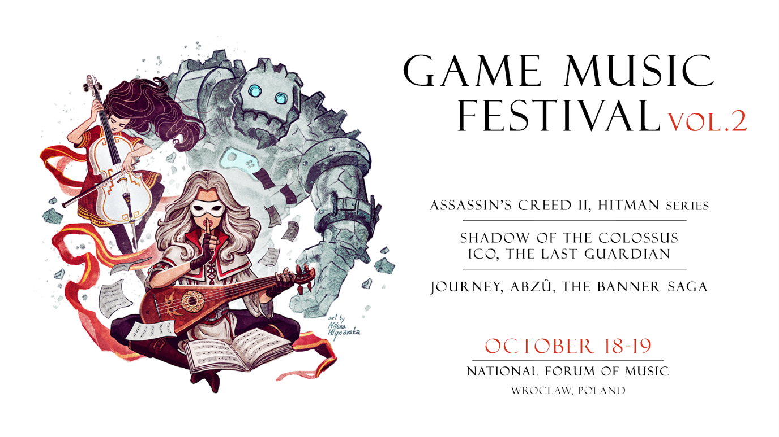
Published on 14th May 2019 – Two days, three concerts, workshops, meetings with composers, and panel discussions. The details of the second edition of the Game Music Festival in Wroclaw, Poland, have been unveiled. A fully-fledged festival of this scale dedicated to the soundtracks of video games is a truly unique event. During the 18thand 19th of October 2019, a total of several hundred musicians will appear on the stage of the National Forum of Music. The previous edition of Game Music Festival received much praise and was well acclaimed by fans and composers alike, attracting an audience of over 5,000 participants total. There will be multiple accompanying events this time as well. The whole initiative is organized by the Game Music Foundation, and tickets are already available for purchase.
The first concert of this year’s Game Music Festival – The Symphony of the Desert – is based on the idea of contrast between three incredibly atmospheric titles: Journey, Abzu, The Banner Saga. The former two soundtracks are subtle and have an ethereal beauty, while the third one is full of piercing cold and raw in its form. The author of those pieces, which add lots of value to their respective games, is the acclaimed American composer Austin Wintory. Sound Factory Orchestra led by Robert Kurdybacha, an ensemble that played the amazing concert with the music from Ori and the Blind Forest during the first GMF, will take listeners on a journey through endless deserts, vast sea depths, and snowy mountains.
The Symphony of the Colossus, being the second concert of this year’s Festival, is dedicated to the music of three timeless games: ICO, Shadow of the Colossus, The Last Guardian. Players remember these titles not only because of the bond with their protagonists and a minimalist narrative but also thanks to their soundtracks full of monumental yet delicate melodies. The productions by Fumito Ueda (who is the game designer of all three) always present a profoundly emotional story. The Symphony of the Colossus shall reflect this approach by merging the creations of Japanese composers such as Michiru Oshima, Kow Otani, Takeshi Furukawa. This extraordinary musical adventure will be performed by Sound Factory Orchestra and conducted by Robert Kurdybacha.
The Symphony of the Shadows will be the grand finale of Game Music Festival 2019. It is a synthesis of music accompanying two stealthy assassins, as well as an homage to the audio design of their missions – Ezio Aduditore from Assassin’s Creed II together with Agent 47 from the Hitman series. The music to both amazing games was composed by Jesper Kyd. These two powerful suites will be performed live by over 120 musicians in total, the full NFM Wroclaw Philharmonic Orchestra with a choir. This year marks the 10th anniversary of the release of Assassin’s Creed II and the 20th of the first Hitman title. The distinct, moody soundtracks of these games present two worlds which may seem completely different yet actually have much in common. The themes which will resound on the 19th of October in the National Forum of Music were created over a timespan of two decades. This concert will let the audience discover them anew and appreciate all the musical details without a hurry.

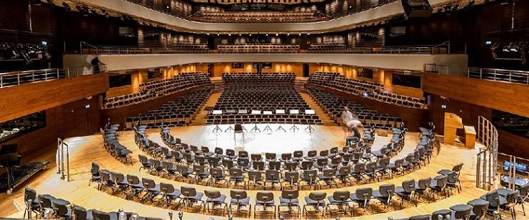

The Game Music Festival is produced by the team of gamemusic.pl. The organizers say that the idea of the festival is not only to give fans the opportunity to enjoy live music form their favorite games in acoustic versions but also to gather composers and audio professionals of the video game industry. They want to create a common space for workshops, lectures, and discussions: “We focus on the highest artistic quality, that is why once again we decided to cooperate with the National Forum of Music which has one of the best philharmonic halls in the world in terms of sheer acoustics. Thanks to this, we can provide the performances without any electronic amplification, contrary to what would happen in a sports arena or other objects. We really want the festival to be also an educational event, where fans can get acquainted with the process of making music for games. Furthermore, we want GMF to be of a forum for meetings of experts, sound designers, and composers working in the gaming industry” – say the organizers.

The venue:
The Witold Lutoslawski National Forum of Music (NFM) is an impressive edifice located in Wroclaw, Poland. The perfect acoustics of its concert halls put it among the very best objects of its kind in the world. Moreover, the concert halls have innovative systems for programming acoustics, including the shifting ceiling in the main concert hall and an air margin encircling it, allowing to control the length of reverberation.

The artists:
The music will be played by the NFM Wroclaw Philharmonic and the Sound Factory Orchestra. The NFM’s symphonic orchestra was founded in 1945, and since then it has been delivering dozens of unique projects, also promoting Polish music around the world. Sound Factory Orchestra is a multimedia project that was created in 2009. Its mission is to promote and popularize projects related to contemporary art, primarily in the field of music and visual arts. Beside the NFM Orchestra and Sound Factory Orchestra, there will be more performers on the Festival’s stage, including the NFM Choir.

The score:
Unique musical scores were written specially for all four concerts of the Festival. They were created by several composers and arrangers, including Jan Sanejko, Aruto Matsumoto, and Robert Kurdybacha – all of them being brilliant and very talented artists who worked with video game soundtracks previously. The whole process was supervised by the creators of the original music and publishers of the games.

The tickets:
The price range of tickets for this event starts from 59 PLN and rises depending on the location of the seat. Combined passes for all festival concerts start from 359 PLN. Strictly limited VIP vouchers are also available – they include meetings with all composers that will appear at the festival, as well as entry to all accompanying events. All tickets are being sold online avia the Ticketmaster portal. For the latest news, follow the event’s Facebook site.

ABOUT GAMEMUSIC.PL
We are a group of individuals passionate about the music of video games. Our team works at gamemusic.pl which has been one of the most active and comprehensive portals dedicated to game audio for over 13 years now. We are based in Poland, but our mission spreads internationally. Our activities include soundtrack reviews, interviews with composers, organization of events, workshops, and discussion panels. We also run gamemusic records, a label releasing game music on vinyls.


MEDIA CONTACT
Game Music Foundation
festival@gamemusic.pl

© Copyright 2019 Game Music Foundation

