FOR RELEASE SINCE OCTOBER 30, 2023

Game Music Festival in London, 4th of May 2024
The Last of Us, Baldur’s Gate 3
Two different genres, two distinct styles, one unique event.
The Game Music Foundation presents The Sounds of the Fireflies – an orchestral rendition of The Last of Us score, paired with The Symphony of the Realms, a symphonic concert featuring music from Baldur’s Gate 3. Southbank Centre’s Royal Festival Hall will resonate with the sound of video game music once more!

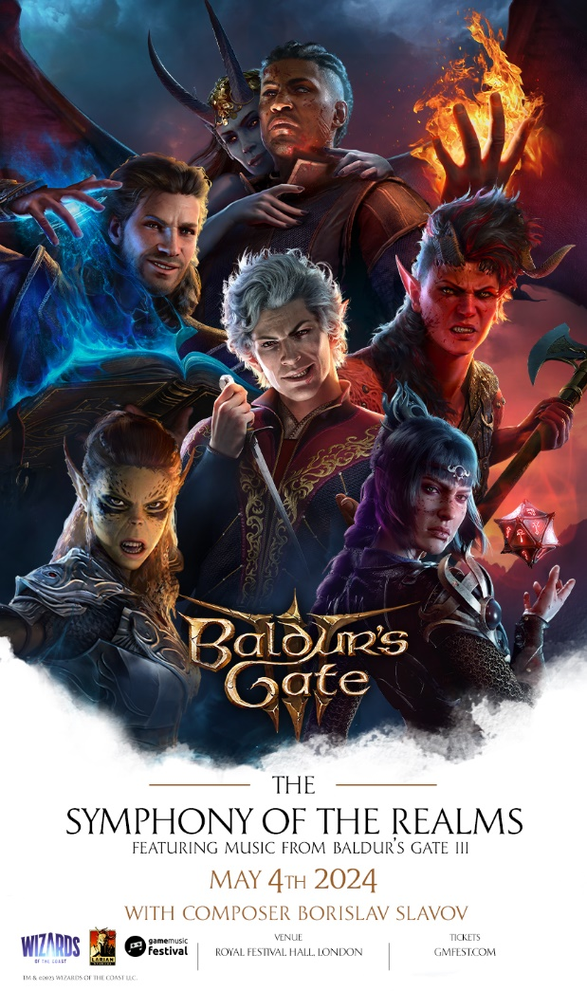

London, UK – 30th October 2023 – The Game Music Foundation is pleased to announce the fifth edition of the universally acclaimed Game Music Festival. On 4th May 2024, London’s Royal Festival Hall at Southbank Centre will once again host a celebration of the art of video game music with two live concerts featuring music from The Last of Us franchise and Baldur's Gate 3. Additionally, an educational programme scheduled for the same day will allow music enthusiasts and aspiring composers to join masterclasses, panel discussions, and provide an opportunity to meet the brilliant minds behind the featured soundtracks.
Tickets are already available for purchase at gmfest.com.
Game Music Festival 2024 will begin with The Sounds of the Fireflies, a musical journey through unforgiving yet hopeful world of The Last of Us. With 80 awards total, over 17 million copies sold, and TV adaptation being HBO Max’s most-watched project in history, both parts of Naughty Dog’s masterpiece left a strong imprint in hearts of gamers all over the world. BAFTA-nominated original scores composed by Oscar-winning guitar virtuoso Gustavo Santaolalla perfectly resonate with the emotional landscape of the game. From haunting, life-threatening situations to sombre, melancholic moments and gut-wrenching decisions – his music amplifies each scene, creating a synergistic, emotional spectacle. To enhance the show even further, Gustavo Santaolalla himself will appear on stage alongside the Philharmonia Orchestra in a performance set to captivate hearts and minds, ensuring an extraordinary experience for all attendees.
Taking the gaming world by storm, applauded by critics, and loved by fans – Baldur’s Gate 3, a recent entry to the legendary role-playing game franchise makes its epic musical debut with The Symphony of the Realms, the second concert of Game Music Festival 2024. A beautifully crafted world, great cast of characters, engrossing story, and freedom of choice accompanied by Borislav Slavov’s mesmerising music undoubtedly contributed to the staggering success of Baldur’s Gate 3. Different facets of player’s adventures are perfectly reflected in the soundtrack, likely to charm the listeners with delicate melodies, as well as inspire them with monumental battle themes. This performance by the Philharmonia Orchestra, joined by Hertfordshire Chorus, will take the audience on an unforgettable adventure through Forgotten Realms. Borislav Slavov himself will be a special guest during the event.

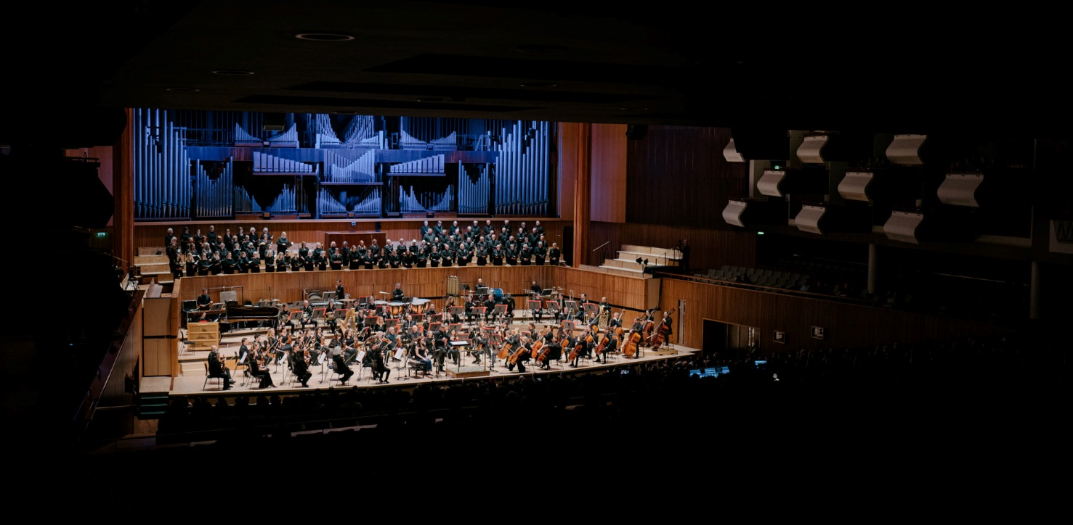

Game Music Festival is not exclusively about the concerts, it also features multiple educational events. Between the shows on Saturday 4th May, the GMF 2024 educational programme will take place, hosting masterclasses and various sessions. Participants will be able to meet industry professionals, improve their skills, and learn tips and tricks from the field of contemporary game music production. Attending these events can be invaluable for anyone planning to dive into composing or designing sound in games. Further details of the educational programme will be unveiled later.
“We are truly excited to present the Game Music Festival in London again.” Commented Marta and Mateusz Pawlak, founders of Game Music Festival. “The previous editions of GMF clearly show that it is the perfect spot to showcase what our festival is all about – celebrating the art of video game music. Like previous editions, we fully dedicate ourselves and spare no effort to deliver a remarkable musical experience to our audience. The very core of our mission is promoting the video game music genre, and with the repertoire we have this year, we aim to gather the attention of gaming communities and fans of illustrative music alike. We hope that both our regular audience as well as newcomers will be pleased with the result at London's Southbank Centre”.
For the latest updates, be sure to follow the event’s Facebook page and subscribe to the official newsletter.
Tickets:
Ticket prices start from 40 GBP per concert, and rise according to seat location. Strictly limited VIP vouchers are also available – they include premium seating, as well as admissions to a masterclass with the composer of given music who will appear at the festival, live and in person. All tickets are now available at gmfest.com.

Venue:
The Royal Festival Hall is a truly impressive artistic venue located within Southbank Centre in London. With an impressive history of over 70 years of hosting prominent musicians, it stands among the world’s leading concert halls. The stunning interior design of the Royal Festival Hall is matched only by its crystal-clear acoustics. The concert space itself is renowned worldwide for its crisp sound.

Artists:
The famous Philharmonia Orchestra will perform both The Sounds of the Fireflies and – joined by the Hertfordshire Chorus – The Symphony of the Realms, displaying their mastery over music from diverse genres. They are no strangers to such arrangements, having performed the The Symphony of the Spirits during the 2022 edition of Game Music Festival. Gustavo Santaolalla, the brilliant mind behind each of The Last of Us soundtracks, will join the stage to demonstrate his proficiency with guitar during The Sounds of the Fireflies. Both concerts will be conducted by maestro Robert Kurdybacha, a long-time associate of GMF who has arranged and conducted several fan-favourite symphonies for previous editions of the festival.



About the Game Music Foundation:
The Game Music Foundation is formed by a group of individuals passionate about the music of video games. Our team created gamemusic.net which has been one of the most active and comprehensive portals dedicated to game audio since 2006. GMF is based in Poland, but its mission is international. GMF also run Gamemusic Records, a label releasing game music on vinyl, such as the Frostpunk and Heroes of Might & Magic soundtracks, as well as Gamemusic Magazine, the first-ever paper magazine devoted entirely to video game music.

Media contact:
The Game Music Foundation
festival@gmfest.com

© Copyright 2023 Game Music Foundation.

