FOR IMMEDIATE RELEASE
NOVEMBER 11, 2021

Game Music Festival in London
5-6th of March 2022
The Game Music Foundation presents a big-band ensemble playing the jazz age soundtrack of Cuphead, followed by a symphonic concert featuring music from Ori and the Will of the Wisps, as well as Ori and the Blind Forest– all performed live at London’s Royal Festival Hall, for an event fully devoted to the music of video games. Tickets are already available online.
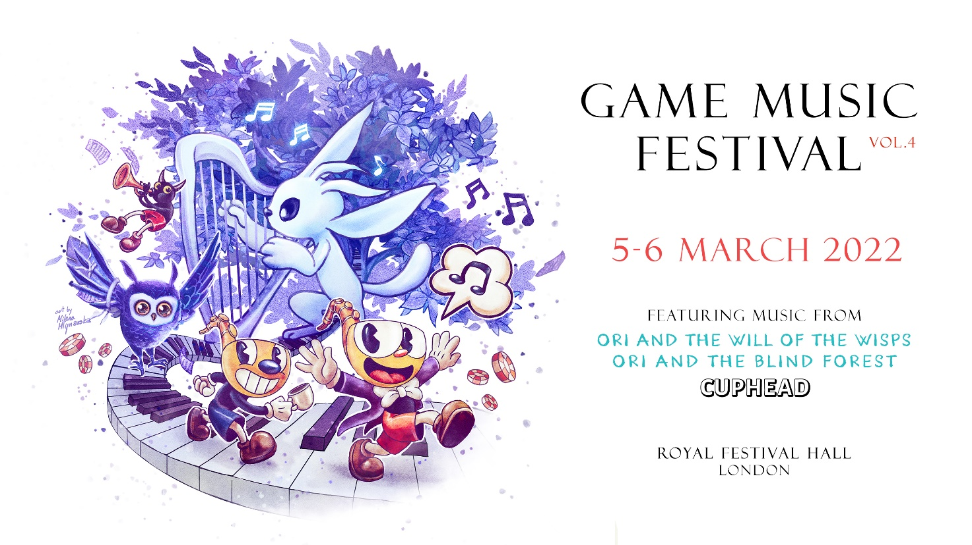

London, UK – The details of the 2022 edition of the Game Music Festival have been unveiled. This time, the fully fledged festival dedicated to video game soundtracks will take place at the famous Royal Festival Hall in London. On the 5th and 6th of March 2022, the venue will play host to original arrangements of fan-favourite video game soundtracks, as well as various accompanying events. An educational programme will take place on the first day, while the second day will be dedicated to live concerts. The three previous editions of the Game Music Festival have been praised by fans worldwide, attracting an audience of over 12,000 on-site guests in total. The whole initiative is organised by the Game Music Foundation, and tickets are now available for purchase at gmfest.com.
The Jazz of Cuphead is the first concert at GMF 2022. The exuberant jazz score of Cuphead, an unmistakably stylish platformer, will be interpreted on stage by a seasoned big band. Full of early styles of jazz mixed with ragtime music, the original soundtrack of Cuphead swiftly transports the listener to a world inspired by Duke Ellington and Count Basie, but always with a twist. All of this has led to Cuphead winning the well-deserved BAFTA Games Award for Best Music. Cuphead’s composer, Kristofer Maddigan, will join the audience to see his score brought to life by the Bartosz Pernal Orchestra – an ensemble of experienced musicians led by a charismatic trombone player.

Lauded by critics and millions of fans worldwide upon release , Ori and the Will of the Wisps was soon hailed as a masterpiece, with special merit given to its unforgettable score by Gareth Coker, a multi-BAFTA-nominated composer and winner of the 2021 Ivor Novello Award for Best Original Video Game Score. Together with Ori and the Blind Forest, both of these universally acclaimed soundtracks comprise the musical programme of The Symphony of the Spirits, the second concert of Game Music Festival 2022. These arrangements have been created by maestro Robert Kurdybacha, who is no stranger to the music of video games – he has arranged several fan-favourite symphonies for previous editions of the festival. Gareth Coker will also attend this very special occasion at the Royal Festival Hall. The performance by the Philharmonia Orchestra and Hertfordshire Chorus will take the audience on a journey through Ori’s world as never before.

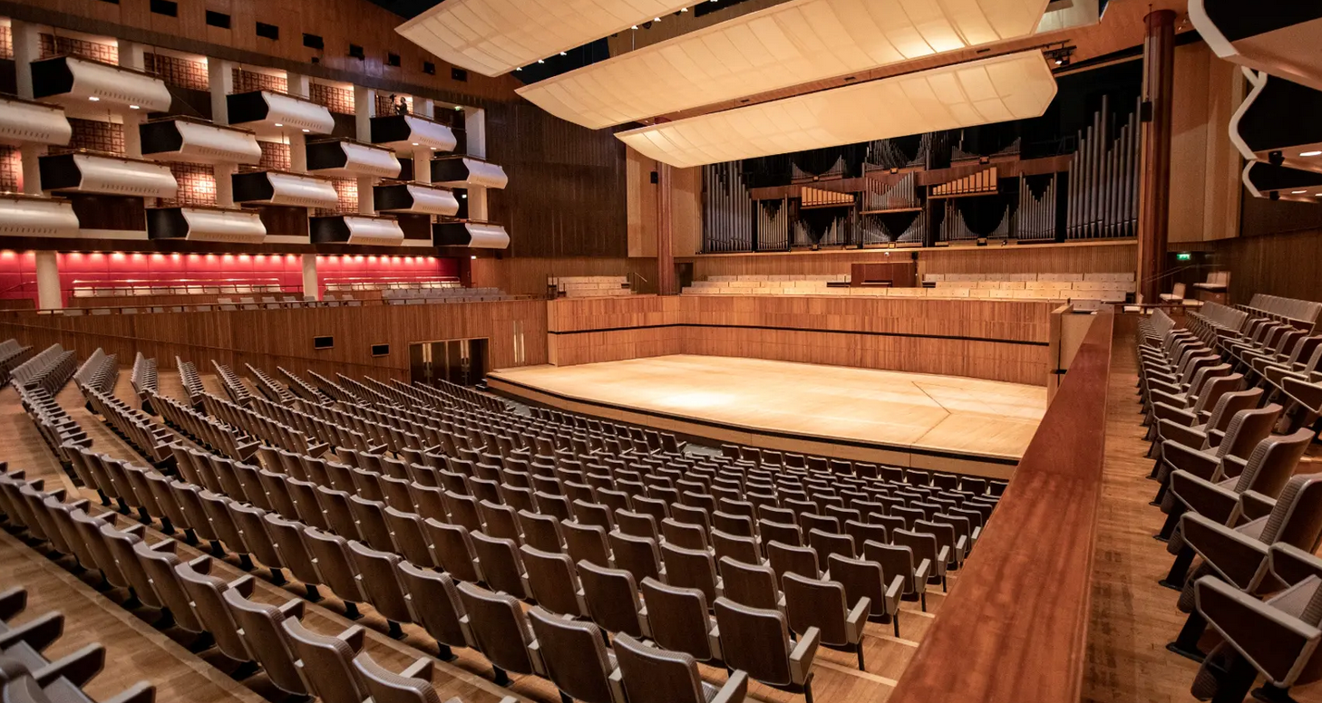

Game Music Festival will not only present these concerts, but also multiple educational events. On Saturday the 5th of March, the GMF 2022 educational programme will host masterclass workshops and other sessions, where participants will be able to see behind the scenes of how audio is created for games, improve their skills and learn many tips and tricks in the field. Details of the educational programme will be unveiled later on. These sessions will be a unique opportunity to have a closer look into the world of music and sound in contemporary video games. This will be a great event for anyone who plans to build a career composing or designing sound in games.
As the organisers say: “This time the festival will be held in London, but apart from changing the venue, our approach remains consistent: we aspire to maintain high artistic quality which has become the hallmark of GMF. As in previous editions, we extract the musical essence of selected games to present them in a way that will satisfy not only the fan community but also music lovers in general. Besides the two big concerts, we also invite you to the educational programme which will once again be a forum for the exchange of knowledge and experience for audio professionals. We hope that both our regular audience as well as newcomers will be pleased with the end result at London's Southbank Centre.” For the latest updates, be sure to follow the event’s Facebook page.

Tickets:
Ticket prices start from 25 GBP per concert and rise according to seat location. Strictly limited VIP vouchers are also available – they include the best seats, as well as meetings with all composers that will appear at the festival (in person or online). All tickets are being sold via gmfest.com.

Venue:
The Royal Festival Hall is a truly impressive artistic venue located within Southbank Centre in London. With a history of over 70 years of hosting prominent musicians, it stands among the world’s leading concert halls. The stunning interior design of the Royal Festival Hall is matched only by its crystal clear acoustics. The concert space itself is renowned worldwide for its crisp sound.

Artists:
The Symphony of the Spirits will be performed by the famous Philharmonia Orchestra and Hertfordshire Chorus – they shall take the audience on a journey through Ori’s world as never before. Woodwind soloist Kristin Naigus is along for the ride: she performed all of Ori’s specialist woodwinds in the original soundtrack. The Jazz of Cuphead will be played by the Bartosz Pernal Orchestra, a true highlight among contemporary European big bands. They are given the honour of interpreting these pieces on stage, and they are up to the challenge, having already performed The Jazz of Grim Fandango – another tribute to a famous game soundtrack.



About Game Music Foundation:
We are a group of individuals passionate about the music of video games. Our team created gamemusic.net which has been one of the most active and comprehensive portals dedicated to game audio since 2006. We are based in Poland, but our mission is international. We also run Gamemusic Records, a label releasing game music on vinyl, such as the Frostpunk and Heroes of Might & Magic soundtracks, as well as Gamemusic Magazine, the first ever paper magazine devoted entirely to video game music.

MEDIA CONTACT
Game Music Foundation
festival@gamemusic.pl

© Copyright 2021 Game Music Foundation

